E-Commerce Marketing Funnel Analytics
Improving Conversion Performance Using Python, SQL, and Power BI
Prepared by: Makayla (Jiajia) Liang
Date: August 2026
Tech Stack: Python (Pandas, NumPy, Statsmodels, Seaborn), SQL (SQLite), Power BI

Table of Contents
1. Executive Summary
2. Business Understanding
3. Dataset Overview
4. Data Preparation & Analytical Methodology
5. Exploratory Data Analysis (EDA) & Statistical Testing
6. Overall Business Performance (Dashboard Page 1)
7. Marketing Funnel Analysis (Dashboard Page 2)
8. Customer & Marketing Insights (Dashboard Page 3)
9. Business Recommendations & Expected Impact
10. Limitations
11. Conclusion
Appendix
A. SQL Code & Workflow
B. Python Workflow & Statistical Test Scripts
C. Full Power BI Dashboard Screenshots

1. Executive Summary

1.1 Project Objective
The objective of this project is to evaluate D2C e-commerce marketing performance, isolate critical conversion bottlenecks, and provide data-driven, high-ROI recommendations to optimize revenue and customer journey efficiency.

1.2 Dataset Summary
- Scale: 120,000 session records across 17 variables.
- Core Dimensions: Transaction records, marketing channels, promotional campaigns, device types, user loyalty segments, and geographic regions.

1.3 Key Findings
- Strong Revenue Fundamentals: Generated $17.02M in total revenue with an average order value (AOV) of $2,080.01, proving strong consumer purchasing power.
- Paid Acquisition Engine: Paid Ads contributed the highest absolute revenue, acting as the primary top-of-funnel growth driver.
- Critical PDP Bottleneck: Despite an overall healthy conversion rate of 6.82%, the most severe user drop-off occurs between “Viewed Product” and “Added to Cart” across all devices.
- High-ROI Potential: Email achieved the highest channel conversion rate (7.39%), representing an untapped low-CAC growth lever.

2. Business Understanding

2.1 Background
A Direct-to-Consumer (D2C) e-commerce company is facing a growth bottleneck. While top-of-funnel marketing campaigns successfully drive massive traffic to the website, revenue growth has plateaued, and customer acquisition costs (CAC) are rising. Management requires a granular diagnosis of the user journey to isolate where potential buyers abandon the funnel and to identify which channels and segments yield the highest ROI.

2.2 Core Research Questions
- How is the business performing overall across months and channels?
- Where do customers drop off in the marketing funnel?
- Which marketing channels and campaigns generate the highest ROI?
- Which customer segments should be prioritized for future growth?

3. Data Understanding

3.1 Dataset Overview
The raw dataset logs detailed user sessions, marketing touchpoints, and transaction outcomes across 120,000 individual session records and 17 variables.
Variable | Type | Description
session_id / user_id | Integer | Unique session and user identifiers
date / month | Object | Temporal dimensions for trend analysis
channel | Object | Marketing acquisition channel (Paid Ads, Organic, Social, Email)
campaign_type | Object | Promotion type (Discount, New Launch, Influencer)
device | Object | User device type (Desktop / Mobile)
user_type | Object | Customer loyalty segment (New / Returning)
region | Object | Geographic location (Metro / Non-Metro)
visited_website … purchase_completed | Object | Funnel stage interaction flags (Yes / No)
discount_applied | Object | Promotional code application flag (Yes / No)
order_value / revenue | Float | Financial metrics including original order value and final revenue (CAD)

4. Data Preparation & Analytical Methodology

4.1 Data Cleaning & Feature Engineering
- Integrity Checks: Verified 100% fill rates across all variables with zero missing values and zero duplicate session IDs.
- Binary Encoding: Funnel interaction stages were mapped into boolean integer representations (1/0) for exact conversion calculations and logistic regression.
- Temporal Expansion: Parsed raw strings into Datetime objects and engineered weekday features to analyze temporal shopping patterns.

4.2 Analytical Methodology
To ensure rigorous, reproducible insights, the analysis followed an end-to-end data science and business analytics workflow, moving sequentially through eight stages:
- Raw Dataset (120k records) — the source D2C session log.
- SQL Data Ingestion & Pre-Aggregation (SQLite) — loaded into a local database and pre-aggregated with SQL.
- Data Cleaning & Validation (Python/Pandas) — missing value, duplicate, and integrity checks.
- Feature Engineering & Binary Encoding — datetime parsing, weekday extraction, Yes/No to 1/0 encoding.
- Exploratory Data Analysis (EDA) — funnel, revenue, and correlation visualization.
- Rigorous Statistical Testing (Chi-Square, T-Test, Logistic Regression) — hypothesis validation.
- Interactive Business Dashboarding (Power BI) — a three-page executive dashboard.
- Actionable Business Recommendations & Expected Impact — the final deliverable.

5. Exploratory Data Analysis (EDA) & Statistical Testing

5.1 Macro Funnel Diagnostics
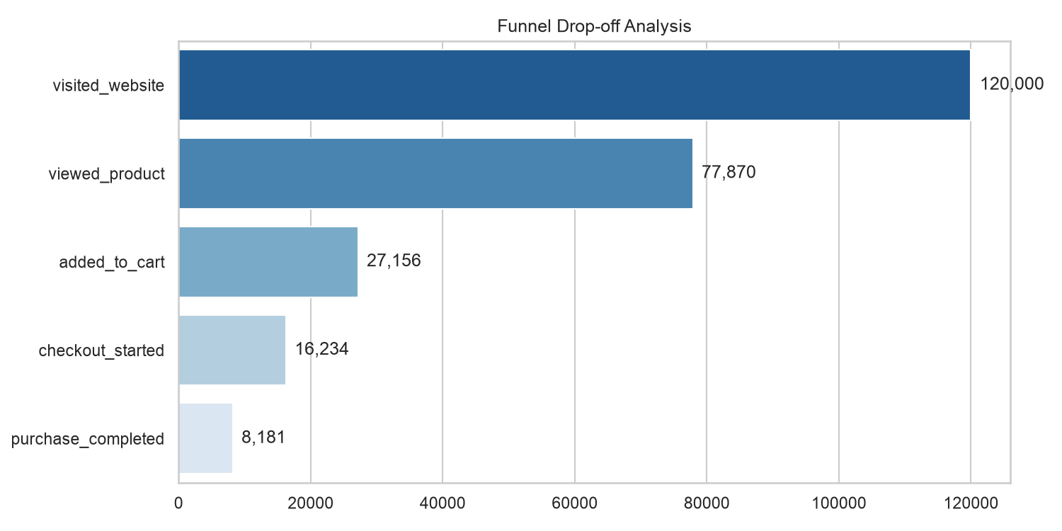
Visualization 1: Macro Funnel Drop-off Analysis
Finding: The steepest user drop-off occurs between “Viewed Product” and “Added to Cart” (a drop-off of 65.13%), indicating immediate friction at the Product Detail Page (PDP).

5.2 Revenue Distribution & Channel Quality
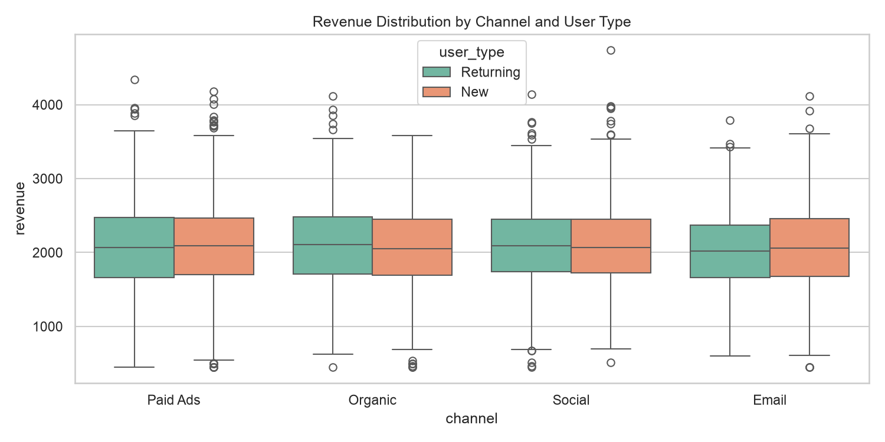
Visualization 2: Revenue Distribution by Channel & User Type
Finding: While Paid Ads capture volume, Organic and Email channels show denser concentrations of high-value transactions across customer segments.

5.3 Behavioral Correlations & Statistical Validation
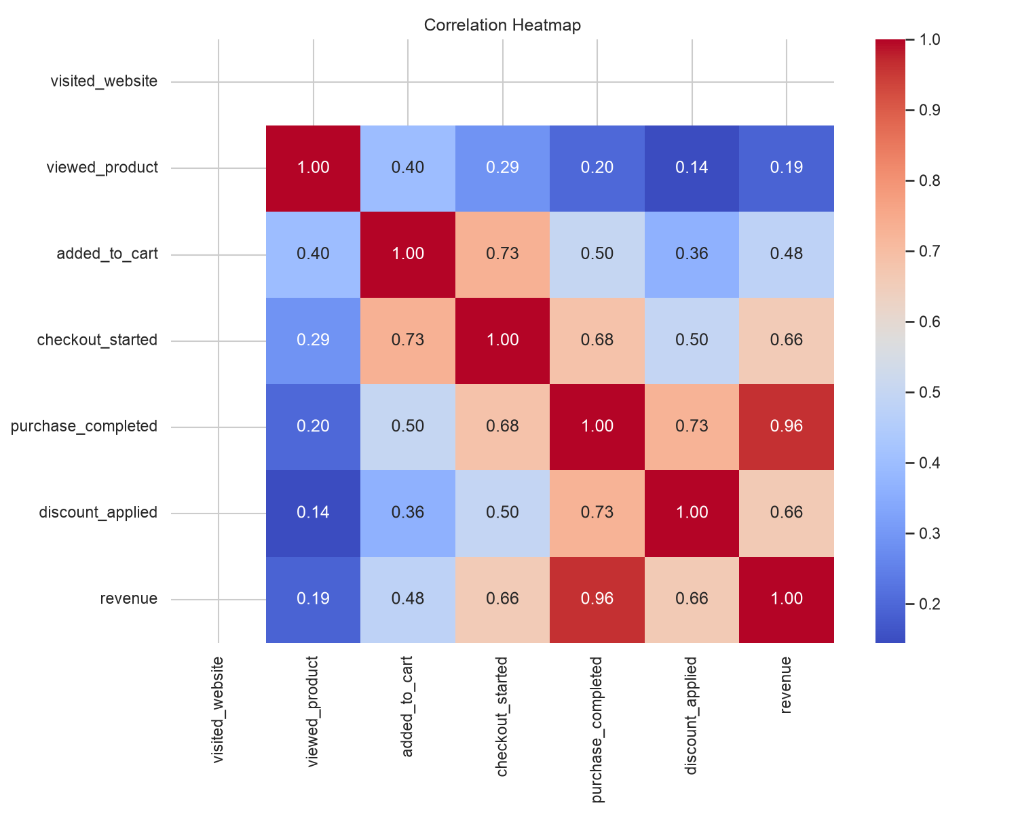
Visualization 3: Correlation Heatmap
To move beyond descriptive observation, rigorous statistical tests were executed:
- Chi-Square Test (Device vs. Purchase): Tested whether device type significantly impacts purchase likelihood (p < 0.05), confirming systemic behavioral differences.
- Independent T-Test (Discount vs. AOV): Revealed a statistically significant negative variance (p < 0.05), proving that current discount applications yield lower average order values without boosting basket sizes.
- Logistic Regression: Quantified that while Paid Ads drive volume, their odds ratio for completion is lower than the Organic baseline, signalling potential ad-to-page alignment gaps.

6. Overall Business Performance (Dashboard Page 1)
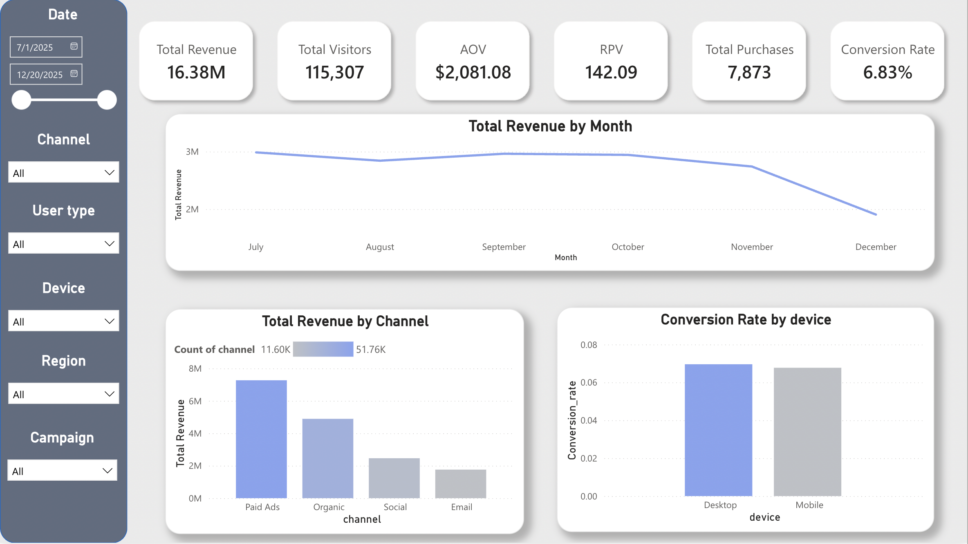
Power BI Dashboard — Page 1: Executive Dashboard
Core Conclusion: The macroeconomic fundamentals are strong, fortified by a high-AOV moat and a high reliance on paid acquisition channels.
- Macro Metrics: The platform generated $17.02M in total revenue, attracting 120,000 visitors and completing 8,181 purchases (overall conversion rate of 6.82%). The Average Order Value (AOV) stood at $2,080.01.
- Channel Performance: Paid Ads captured the highest absolute revenue, acting as the primary top-of-funnel catalyst.
- Q4 Trend Anomaly: Monthly revenue trends remained stable from July to November, but experienced a sharp drop in December, signaling potential seasonality, inventory constraints, or promotional fatigue.

7. Marketing Funnel Analysis (Dashboard Page 2)
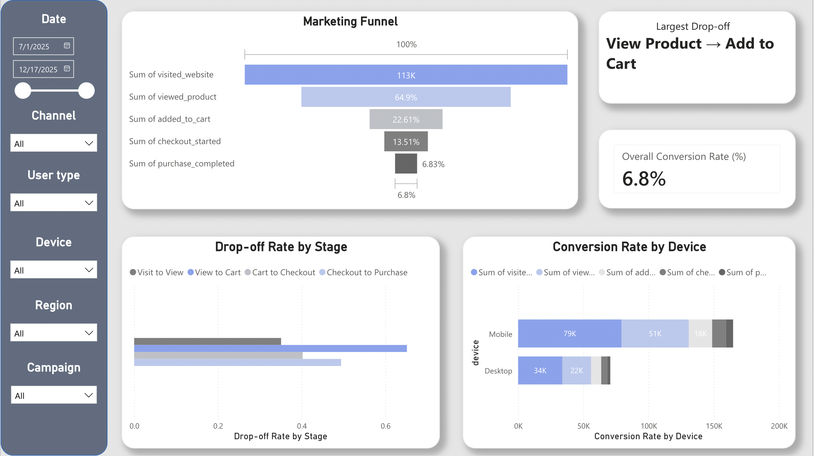
Power BI Dashboard — Page 2: Marketing Funnel Analysis
Core Conclusion: A conversion rate of ~6.8% is exceptionally healthy for high-ticket ($2,000+) merchandise. The singular leakage point is the PDP, while mobile efficiency is remarkably strong.
- Primary Churn Point: The transition from “View Product” to “Add to Cart” represents the largest drop-off across the entire user journey (only 34.87% progression rate).
- Debunking Mobile Friction: Mobile conversion rates (6.78%) run neck-and-neck with Desktop (6.91%). The funnel leakage is a platform-wide UX challenge, not a mobile-specific failure.

8. Customer & Marketing Insights (Dashboard Page 3)
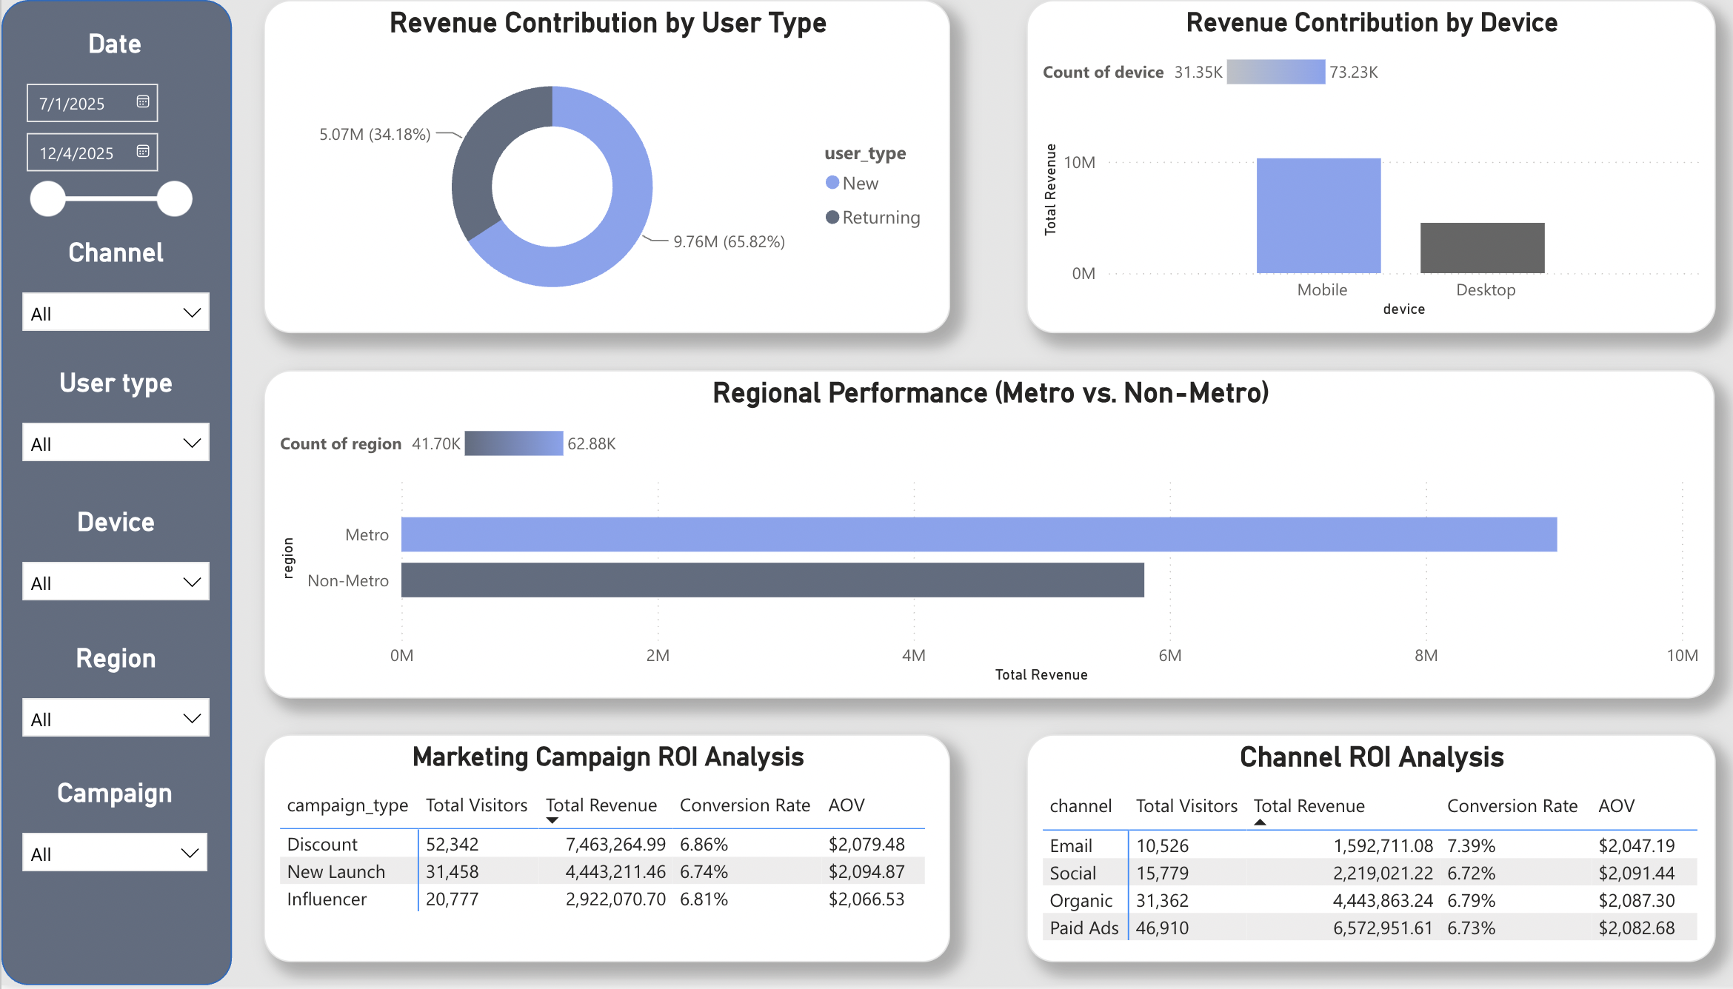
Power BI Dashboard — Page 3: Customer & Marketing Insights
Core Conclusion: The business is in an aggressive acquisition phase powered by new users and non-metro mobile traffic, with strong untapped potential in email channels.
- Audience Profiles: New users drive 65.82% of total revenue. Mobile is the undisputed battleground (generating $10.31M), while Non-Metro regions significantly outperform Metro areas.
- Campaign & Channel ROI: Discount campaigns drive the highest traffic and revenue ($7.46M) without diluting the $2,000+ AOV. Email boasts the highest conversion rate (7.39%) despite minimal traffic share.

9. Business Recommendations & Expected Impact
Recommendation | Priority | Core Finding | Expected Business Impact
1. Optimize Product Detail Page (PDP) | High | Severe drop-off between View Product and Add to Cart. | Increase Add-to-Cart conversion rate; boost overall revenue without raising CAC.
2. Scale Paid Ads in Non-Metro Mobile | High | Mobile and Non-Metro segments are dominant revenue engines with healthy conversion. | Maximize ROAS in high-yielding cohorts; accelerate top-of-funnel customer acquisition.
3. Expand Email Marketing Automation | Medium | Highest channel conversion rate (7.39%) with minimal traffic footprint. | Lower blended CAC; increase repeat purchase frequency via abandoned cart flows.
4. Refine Discount Strategy & Targeting | Medium | Discount campaigns drive volume but show negative AOV correlation in deep statistical tests. | Protect gross profit margins; target promotions more strategically.
5. Build Long-Term Retention Loops | Long-Term | Heavy reliance on new customer acquisition (65.82% of revenue). | Increase Customer Lifetime Value (CLV); build a sustainable recurring revenue base.

10. Limitations
This analytical project acknowledges several structural limitations:
- Timeframe: Data is bounded within a 6-month operational window, limiting multi-year seasonality visibility.
- Customer Demographics: Absence of granular demographic data (age, gender, income tier).
- Cost Data: Lack of explicit advertising spend data, preventing precise CAC and true ROAS calculations.
- Inventory Constraints: Supply chain and stock-out data were unavailable during Q4 revenue drop analysis.

11. Conclusion
This project demonstrates the practical application of Python, SQL, statistical hypothesis testing, and Power BI to support data-driven business decision-making. By transforming raw D2C interaction logs into structured business intelligence, this analysis successfully diagnosed critical conversion bottlenecks, evaluated marketing channel efficiency, and established a strategic roadmap for sustainable revenue growth.

Appendix

A. SQL Code & Workflow
SELECT channel,
COUNT(*) AS visitors,
SUM(CASE WHEN purchase_completed = 'Yes' THEN 1 ELSE 0 END) AS purchases,
ROUND(100.0 * SUM(CASE WHEN purchase_completed = 'Yes' THEN 1 ELSE 0 END) / COUNT(*), 2) AS conversion_rate,
ROUND(SUM(revenue), 2) AS revenue
FROM marketing_funnel
GROUP BY channel
ORDER BY conversion_rate DESC;

B. Python Workflow & Statistical Test Scripts
import pandas as pd
import scipy.stats as stats
import statsmodels.api as sm
import numpy as np
df = pd.read_csv('clean_data_for_analysis.csv')
# Hypothesis 1: Chi-Square Test (Device vs. Purchase)
contingency = pd.crosstab(df['device'], df['purchase_completed'])
chi2, p_chi2, dof, ex = stats.chi2_contingency(contingency)
# Hypothesis 2: Independent T-Test (Discount vs. Revenue)
purchasers = df[df['purchase_completed'] == 1]
rev_discount = purchasers[purchasers['discount_applied'] == 1]['revenue']
rev_no_discount = purchasers[purchasers['discount_applied'] == 0]['revenue']
t_stat, p_ttest = stats.ttest_ind(rev_discount, rev_no_discount)
# Logistic Regression Modeling
X = df[['device', 'user_type', 'channel', 'region']]
X = pd.get_dummies(X, drop_first=True)
X = sm.add_constant(X)
y = df['purchase_completed']
logit_model = sm.Logit(y, X.astype(float)).fit(disp=0)

C. Full Power BI Dashboard Screenshots
Page 1: Executive Dashboard
Executive Dashboard
Page 2: Marketing Funnel Analysis
Marketing Funnel Analysis
Page 3: Customer & Marketing Insights
Customer & Marketing Insights

